Ministry of Education and Science of Ukraine
National Technical University of Ukraine
"Kyiv Polytechnic Institute named after Igor Sikorsky"
Educational and Scientific Institute of Atomic and Thermal Energy
Department of Digital Technologies in Energy

Graphics work
Topic: «Operations on texture coordinates.»
from the discipline: «Visualization of graphical and geometric information»

Variant 6

Performed by:
student of the TP-52mp group
Naumchyk Y.N.

Kyiv – 2025
1.Task

- Reuse texture mapping from Control task.
- Implement texture scaling (texture coordinates) scaling / rotation around user specified point- odd variants implement scaling, even variants implement rotation
- It has to be possible to move the point along the surface (u,v) space using a keyboard. E.g. keys A and D move the point along u parameter and keys W and S move the point along v parameter.

2. Theoretical information
2.1 Parametric Surface Representation
2.1.1 Astroidal Torus Equation
The astroidal torus is defined by the parametric equations:
x(u,v) = (R + a·cos(u))·cos(v)
y(u,v) = (R + a·cos(u))·sin(v)
z(u,v) = a·sin(u)
Where:
u ∈ [0, 2π]: Longitudinal parameter (around the tube)
v ∈ [0, 2π]: Latitudinal parameter (around the central hole)
R: Major radius (distance from center to tube center)
a: Minor radius (tube radius)
2.1.2 Surface Normal Calculation
Surface normals are calculated using partial derivatives:
n(u,v) = (∂p/∂u) × (∂p/∂v)
Where the cross product of tangent vectors provides the normal vector, essential for lighting calculations and normal mapping.
2.2 Texture Coordinate Transformations
2.2.1 Texture Space Representation
Texture coordinates (s,t) ∈ [0,1]² are mapped to surface parameters (u,v). The fundamental texture transformation matrix for 2D coordinates is:
T = [s_x 0 t_x]
[ 0 s_y t_y]
[ 0 0 1 ]

2.2.2 Transformation Hierarchy
Texture transformations follow a specific order to avoid shearing effects:
1. Translation to Origin: Move texture center to (0,0)
T_translate1 = [1 0 -c_x]

[0 1 -c_y]

[0 0 1 ]
2. Scaling: Apply independent scale factors
T_scale = [s_x 0 0]
[0 s_y 0]
[0 0 1]
3. Rotation: Rotate by angle θ
T_rotate = [cosθ -sinθ 0]
[sinθ cosθ 0]
[0 0 1]
2.3 Tangent Space Calculations
2.3.1 TBN Matrix Construction
For normal mapping, we construct a Tangent-Bitangent-Normal (TBN) matrix:
TBN = [T_x B_x N_x]
[T_y B_y N_y]
[T_z B_z N_z]
Where:
T: Tangent vector (direction of increasing u parameter)
B: Bitangent vector (direction of increasing v parameter)
N: Normal vector (perpendicular to surface)
2.3.2 Tangent Space Normal Transformation
Normal map vectors (stored in [0,1] range) are transformed to [-1,1] range and then to world space: world_normal = normalize(TBN × (2 × texture_normal - 1))

2.4 Lighting Model

2.4.1 Phong Reflection Model
The implementation uses the Phong reflection model:
I = I_ambient + I_diffuse + I_specular
Where:
- I_ambient: Constant ambient lighting
- I_diffuse: Lambertian diffuse reflection
- I_specular: Specular highlights based on viewing angle

2.4.2 Light Calculation Components
I_ambient = k_a × I_a
I_diffuse = k_d × (L·N) × I_d
I_specular = k_s × (R·V)^α × I_s
Where α represents material shininess.

2.5 WebGL Rendering Pipeline

2.5.1 Vertex Processing Pipeline
- Vertex attributes → Vertex shader
- Model-view transformation
- Projection transformation
- Viewport transformation
2.5.2 Fragment Processing Pipeline
- Rasterization
- Fragment shader execution
- Depth testing
- Color blending

3. Implementation Details

3.1 Texture Transformation Implementation

3.1.1 Vertex Shader Modifications
The vertex shader was enhanced to include texture transformation calculations:
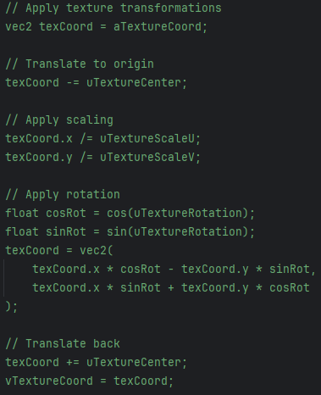
3.1.2 Texture Center Point Visualization
A separate shader program was created for point rendering:
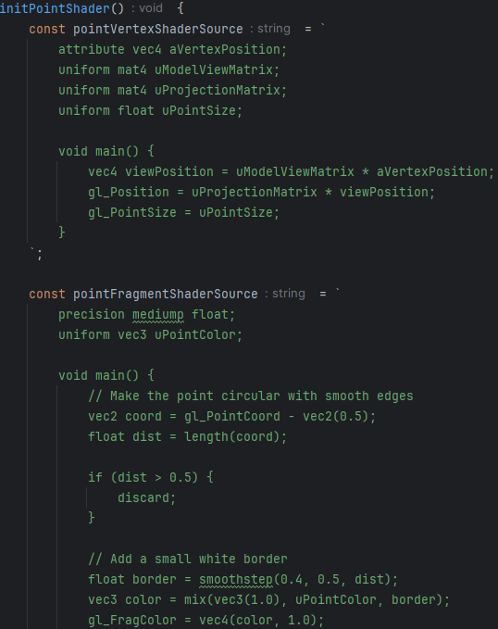

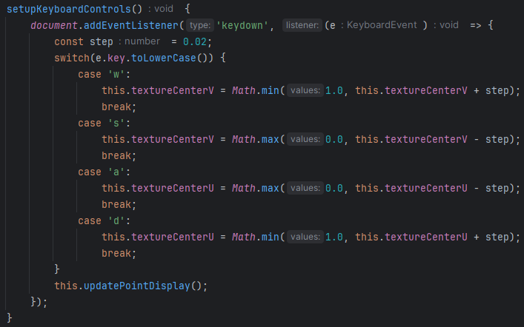
3.2 Interactive Controls Implementation
3.3 Performance Optimizations
Buffer Management
- Vertex buffers are updated only when geometry changes
- Texture transformations are computed in shaders (GPU)
- Point buffer updates only when point position changes
Shader Optimization
- Texture transformations computed per-vertex (not per-fragment)
- Matrix operations minimized through pre-computation
- Conditional branching optimized for GPU execution

4. User's instruction
4.1 Interface Overview

4.1.1 Main Canvas Area
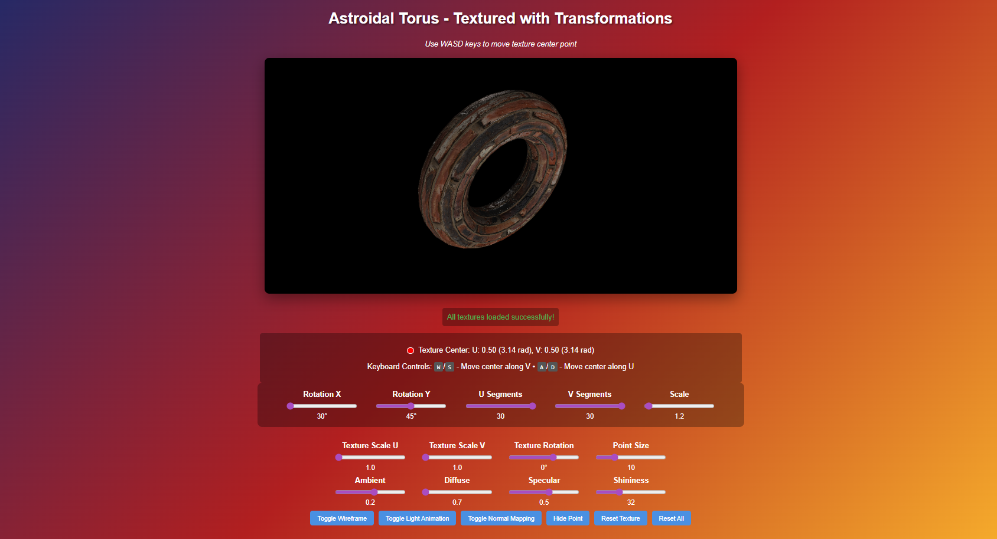
Figure 1 – Main Canvas

The main 3D view displays the astroidal torus with applied textures
4.1.2 Control Panels
A. Rotation Controls
- Rotation X: Tilt the torus forward/backward (0°-360°)
- Rotation Y: Rotate the torus left/right (0°-360°)
B. Geometry Controls
- U Segments: Mesh density along longitudinal direction (10-100)
- V Segments: Mesh density along latitudinal direction (10-100)
- Scale: Overall size of the torus (1.0-10.0)

C. Texture Transformation Controls
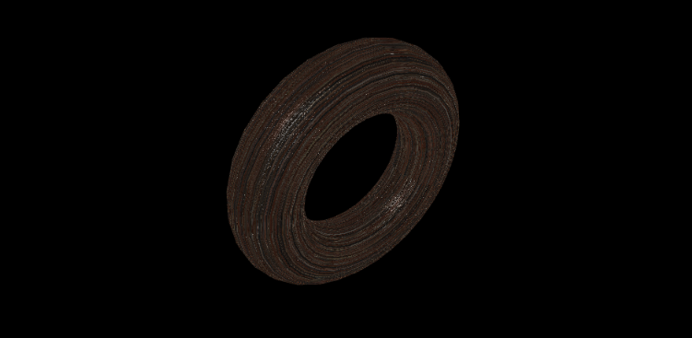
Figure 2 – Torus with applied texture controls

- Texture Scale U: Horizontal texture scaling (0.1-3.0)
- Texture Scale V: Vertical texture scaling (0.1-3.0)
- Texture Rotation: Rotate texture around center point (0°-360°)
- Point Size: Size of transformation point indicator (5-30 pixels)

D. Lighting Controls
- Ambient: Base lighting level (0.0-1.0)
- Diffuse: Directional lighting intensity (0.0-1.0)
- Specular: Highlight intensity (0.0-1.0)
- Shininess: Highlight focus (1-100)

4.2 Step-by-Step Usage Guide

Step 1: Initial Setup
- Open index.html in a compatible web browser
- Wait for textures to load (status shown at top)
- The default view shows the torus at 30° X rotation, 45° Y rotation

Step 2: Basic Navigation
- Use the Rotation X and Rotation Y sliders to orbit around the torus
- Adjust Scale to zoom in/out on the surface
- Increase U/V Segments for smoother surface (may affect performance)

Step 3: Texture Transformation
A. Moving point
- Press W to move point upward in texture space
- Press S to move point downward in texture space
- Press A to move point left in texture space
- Press D to move point right in texture space
Note: The red point on the surface indicates the current transformation center
B. Scaling Textures
- Set Texture Scale U to 2.0 to stretch texture horizontally
- Set Texture Scale V to 0.5 to compress texture vertically
Observe how the texture pattern changes around the red point
C. Rotating Textures
- Move the transformation point to desired location using WASD keys
- Adjust Texture Rotation slider to rotate texture around the point
Watch how the texture pattern rotates while anchored at the red point

Step 4: Advanced Features
- Click Toggle Wireframe to see the underlying mesh structure
- Use Toggle Normal Mapping to enable/disable surface detail enhancement
- Enable Toggle Light Animation for dynamic lighting effects
- Adjust lighting parameters to change the material appearance

Step 5: Reset Functions
- Reset Texture: Returns texture transformations to default values
- Reset All: Returns all settings to initial state
4.3 Visual Feedback Indicators
4.3.1 Status Indicators
- Texture Status: Shows loading progress and completion
- Texture Center: Displays current U/V coordinates in two formats
- Keyboard Info: Shows available controls and current bindings
4.3.2 Visual Cues
- Red Point: Transformation center location on 3D surface
- Texture Pattern: Shows scaling and rotation effects in real-time
- Lighting Response: Immediate feedback on lighting parameter changes

5. Source code

class Model {
constructor(gl) {
this.gl = gl;
this.positionBuffer = gl.createBuffer();
this.normalBuffer = gl.createBuffer();
this.tangentBuffer = gl.createBuffer();
this.bitangentBuffer = gl.createBuffer();
this.textureBuffer = gl.createBuffer();
this.indexBuffer = gl.createBuffer();
this.vertices = [];
this.normals = [];
this.tangents = [];
this.bitangents = [];
this.textureCoords = [];
this.indices = [];
this.uSegments = 30;
this.vSegments = 30;
this.wireframeMode = false;
this.generateSurface();
}
astroidalTorus(u, v) {
const R = 1.5;
const a = 0.5;
const cosU = Math.cos(u);
const sinU = Math.sin(u);
const cosV = Math.cos(v);
const sinV = Math.sin(v);
const x = (R + a * cosU) * cosV;
const y = (R + a * cosU) * sinV;
const z = a * sinU;
return [x, y, z];
}
calculateDerivatives(u, v) {
const epsilon = 0.001;
const p = this.astroidalTorus(u, v);
const pu = this.astroidalTorus(u + epsilon, v);
const du = [pu[0] - p[0], pu[1] - p[1], pu[2] - p[2]];
const pv = this.astroidalTorus(u, v + epsilon);
const dv = [pv[0] - p[0], pv[1] - p[1], pv[2] - p[2]];
return { du, dv };
}
calculateFacetNormal(du, dv) {
const normal = [
du[1] * dv[2] - du[2] * dv[1],
du[2] * dv[0] - du[0] * dv[2],
du[0] * dv[1] - du[1] * dv[0]
];
const length = Math.sqrt(normal[0]*normal[0] + normal[1]*normal[1] + normal[2]*normal[2]);
if (length > 0) {
return [normal[0]/length, normal[1]/length, normal[2]/length];
}
return [0, 0, 1];
}
calculateTangentBitangent(vertex1, vertex2, vertex3, uv1, uv2, uv3) {
const edge1 = [vertex2[0] - vertex1[0], vertex2[1] - vertex1[1], vertex2[2] - vertex1[2]];
const edge2 = [vertex3[0] - vertex1[0], vertex3[1] - vertex1[1], vertex3[2] - vertex1[2]];
const deltaUV1 = [uv2[0] - uv1[0], uv2[1] - uv1[1]];
const deltaUV2 = [uv3[0] - uv1[0], uv3[1] - uv1[1]];
const f = 1.0 / (deltaUV1[0] * deltaUV2[1] - deltaUV2[0] * deltaUV1[1]);
const tangent = [
f * (deltaUV2[1] * edge1[0] - deltaUV1[1] * edge2[0]),
f * (deltaUV2[1] * edge1[1] - deltaUV1[1] * edge2[1]),
f * (deltaUV2[1] * edge1[2] - deltaUV1[1] * edge2[2])
];
const bitangent = [
f * (-deltaUV2[0] * edge1[0] + deltaUV1[0] * edge2[0]),
f * (-deltaUV2[0] * edge1[1] + deltaUV1[0] * edge2[1]),
f * (-deltaUV2[0] * edge1[2] + deltaUV1[0] * edge2[2])
];
return { tangent, bitangent };
}
generateSurface() {
this.vertices = [];
this.normals = [];
this.tangents = [];
this.bitangents = [];
this.textureCoords = [];
this.indices = [];
const uStep = (2 * Math.PI) / this.uSegments;
const vStep = (2 * Math.PI) / this.vSegments;
const vertexNormals = new Array((this.uSegments + 1) * (this.vSegments + 1));
const vertexTangents = new Array((this.uSegments + 1) * (this.vSegments + 1));
const vertexBitangents = new Array((this.uSegments + 1) * (this.vSegments + 1));
for (let i = 0; i < vertexNormals.length; i++) {
vertexNormals[i] = [0, 0, 0];
vertexTangents[i] = [0, 0, 0];
vertexBitangents[i] = [0, 0, 0];
}
for (let i = 0; i <= this.uSegments; i++) {
const u = i * uStep;
for (let j = 0; j <= this.vSegments; j++) {
const v = j * vStep;
const vertex = this.astroidalTorus(u, v);
this.vertices.push(...vertex);
this.textureCoords.push(j / this.vSegments, i / this.uSegments);
const derivs = this.calculateDerivatives(u, v);
const normal = this.calculateFacetNormal(derivs.du, derivs.dv);
vertexNormals[i * (this.vSegments + 1) + j] = normal;
}
}
for (let i = 0; i < this.uSegments; i++) {
for (let j = 0; j < this.vSegments; j++) {
const a = i * (this.vSegments + 1) + j;
const b = a + 1;
const c = (i + 1) * (this.vSegments + 1) + j;
const d = c + 1;
this.indices.push(a, b, c);
this.indices.push(b, d, c);
const vertices = [
[this.vertices[a*3], this.vertices[a*3+1], this.vertices[a*3+2]],
[this.vertices[b*3], this.vertices[b*3+1], this.vertices[b*3+2]],
[this.vertices[c*3], this.vertices[c*3+1], this.vertices[c*3+2]]
];
const uvs = [
[this.textureCoords[a*2], this.textureCoords[a*2+1]],
[this.textureCoords[b*2], this.textureCoords[b*2+1]],
[this.textureCoords[c*2], this.textureCoords[c*2+1]]
];
const tbn1 = this.calculateTangentBitangent(vertices[0], vertices[1], vertices[2], uvs[0], uvs[1], uvs[2]);
for (let k = 0; k < 3; k++) {
const index = [a, b, c][k];
vertexTangents[index][0] += tbn1.tangent[0];
vertexTangents[index][1] += tbn1.tangent[1];
vertexTangents[index][2] += tbn1.tangent[2];
vertexBitangents[index][0] += tbn1.bitangent[0];
vertexBitangents[index][1] += tbn1.bitangent[1];
vertexBitangents[index][2] += tbn1.bitangent[2];
}
const vertices2 = [
[this.vertices[b*3], this.vertices[b*3+1], this.vertices[b*3+2]],
[this.vertices[d*3], this.vertices[d*3+1], this.vertices[d*3+2]],
[this.vertices[c*3], this.vertices[c*3+1], this.vertices[c*3+2]]
];
const uvs2 = [
[this.textureCoords[b*2], this.textureCoords[b*2+1]],
[this.textureCoords[d*2], this.textureCoords[d*2+1]],
[this.textureCoords[c*2], this.textureCoords[c*2+1]]
];
const tbn2 = this.calculateTangentBitangent(vertices2[0], vertices2[1], vertices2[2], uvs2[0], uvs2[1], uvs2[2]);
for (let k = 0; k < 3; k++) {
const index = [b, d, c][k];
vertexTangents[index][0] += tbn2.tangent[0];
vertexTangents[index][1] += tbn2.tangent[1];
vertexTangents[index][2] += tbn2.tangent[2];
vertexBitangents[index][0] += tbn2.bitangent[0];
vertexBitangents[index][1] += tbn2.bitangent[1];
vertexBitangents[index][2] += tbn2.bitangent[2];
}
}
}
for (let i = 0; i <= this.uSegments; i++) {
for (let j = 0; j <= this.vSegments; j++) {
const index = i * (this.vSegments + 1) + j;
// Average normal
const normal = [0, 0, 0];
let count = 0;
for (let di = -1; di <= 1; di++) {
for (let dj = -1; dj <= 1; dj++) {
const ni = i + di;
const nj = j + dj;
if (ni >= 0 && ni <= this.uSegments && nj >= 0 && nj <= this.vSegments) {
const adjNormal = vertexNormals[ni * (this.vSegments + 1) + nj];
normal[0] += adjNormal[0];
normal[1] += adjNormal[1];
normal[2] += adjNormal[2];
count++;
}
}
}
const normalLength = Math.sqrt(normal[0]*normal[0] + normal[1]*normal[1] + normal[2]*normal[2]);
if (normalLength > 0) {
this.normals.push(normal[0]/normalLength, normal[1]/normalLength, normal[2]/normalLength);
} else {
this.normals.push(0, 0, 1);
}
const tangent = vertexTangents[index];
const bitangent = vertexBitangents[index];
const tangentLength = Math.sqrt(tangent[0]*tangent[0] + tangent[1]*tangent[1] + tangent[2]*tangent[2]);
if (tangentLength > 0) {
this.tangents.push(tangent[0]/tangentLength, tangent[1]/tangentLength, tangent[2]/tangentLength);
} else {
this.tangents.push(1, 0, 0);
}
const bitangentLength = Math.sqrt(bitangent[0]*bitangent[0] + bitangent[1]*bitangent[1] + bitangent[2]*bitangent[2]);
if (bitangentLength > 0) {
this.bitangents.push(bitangent[0]/bitangentLength, bitangent[1]/bitangentLength, bitangent[2]/bitangentLength);
} else {
this.bitangents.push(0, 1, 0);
}
}
}
this.updateBuffers();
}
updateBuffers() {
const gl = this.gl;
gl.bindBuffer(gl.ARRAY_BUFFER, this.positionBuffer);
gl.bufferData(gl.ARRAY_BUFFER, new Float32Array(this.vertices), gl.STATIC_DRAW);
gl.bindBuffer(gl.ARRAY_BUFFER, this.normalBuffer);
gl.bufferData(gl.ARRAY_BUFFER, new Float32Array(this.normals), gl.STATIC_DRAW);
gl.bindBuffer(gl.ARRAY_BUFFER, this.tangentBuffer);
gl.bufferData(gl.ARRAY_BUFFER, new Float32Array(this.tangents), gl.STATIC_DRAW);
gl.bindBuffer(gl.ARRAY_BUFFER, this.bitangentBuffer);
gl.bufferData(gl.ARRAY_BUFFER, new Float32Array(this.bitangents), gl.STATIC_DRAW);
gl.bindBuffer(gl.ARRAY_BUFFER, this.textureBuffer);
gl.bufferData(gl.ARRAY_BUFFER, new Float32Array(this.textureCoords), gl.STATIC_DRAW);
gl.bindBuffer(gl.ELEMENT_ARRAY_BUFFER, this.indexBuffer);
gl.bufferData(gl.ELEMENT_ARRAY_BUFFER, new Uint16Array(this.indices), gl.STATIC_DRAW);
}
setSegments(uSegments, vSegments) {
this.uSegments = uSegments;
this.vSegments = vSegments;
this.generateSurface();
}
toggleWireframe() {
this.wireframeMode = !this.wireframeMode;
}
draw(shaderProgram, projectionMatrix, modelViewMatrix, normalMatrix, lightPosition, lightingParams, textures, normalMapping, textureScaleU, textureScaleV, textureRotation, textureCenter) {
const gl = this.gl;
shaderProgram.use();
shaderProgram.setUniformMatrix4fv(shaderProgram.uniforms.projectionMatrix, projectionMatrix);
shaderProgram.setUniformMatrix4fv(shaderProgram.uniforms.modelViewMatrix, modelViewMatrix);
shaderProgram.setUniformMatrix4fv(shaderProgram.uniforms.normalMatrix, normalMatrix);
shaderProgram.setUniform3f(shaderProgram.uniforms.lightPosition, lightPosition[0], lightPosition[1], lightPosition[2]);
shaderProgram.setUniform4f(shaderProgram.uniforms.ambientColor, lightingParams.ambient, lightingParams.ambient, lightingParams.ambient, 1.0);
shaderProgram.setUniform4f(shaderProgram.uniforms.diffuseColor, lightingParams.diffuse, lightingParams.diffuse, lightingParams.diffuse, 1.0);
shaderProgram.setUniform4f(shaderProgram.uniforms.specularColor, lightingParams.specular, lightingParams.specular, lightingParams.specular, 1.0);
shaderProgram.setUniform1f(shaderProgram.uniforms.shininess, lightingParams.shininess);
shaderProgram.setUniform1i(shaderProgram.uniforms.useWireframe, this.wireframeMode ? 1 : 0);
shaderProgram.setUniform1i(shaderProgram.uniforms.useNormalMapping, normalMapping ? 1 : 0);
shaderProgram.setUniform1f(shaderProgram.uniforms.textureScaleU, textureScaleU);
shaderProgram.setUniform1f(shaderProgram.uniforms.textureScaleV, textureScaleV);
shaderProgram.setUniform1f(shaderProgram.uniforms.textureRotation, textureRotation);
shaderProgram.setUniform2f(shaderProgram.uniforms.textureCenter, textureCenter[0], textureCenter[1]);
if (textures.diffuse) {
gl.activeTexture(gl.TEXTURE0);
gl.bindTexture(gl.TEXTURE_2D, textures.diffuse);
shaderProgram.setUniform1i(shaderProgram.uniforms.diffuseTexture, 0);
}
if (textures.specular) {
gl.activeTexture(gl.TEXTURE1);
gl.bindTexture(gl.TEXTURE_2D, textures.specular);
shaderProgram.setUniform1i(shaderProgram.uniforms.specularTexture, 1);
}
if (textures.normal) {
gl.activeTexture(gl.TEXTURE2);
gl.bindTexture(gl.TEXTURE_2D, textures.normal);
shaderProgram.setUniform1i(shaderProgram.uniforms.normalTexture, 2);
}
gl.bindBuffer(gl.ARRAY_BUFFER, this.positionBuffer);
gl.vertexAttribPointer(shaderProgram.attributes.vertexPosition, 3, gl.FLOAT, false, 0, 0);
gl.enableVertexAttribArray(shaderProgram.attributes.vertexPosition);
gl.bindBuffer(gl.ARRAY_BUFFER, this.normalBuffer);
gl.vertexAttribPointer(shaderProgram.attributes.vertexNormal, 3, gl.FLOAT, false, 0, 0);
gl.enableVertexAttribArray(shaderProgram.attributes.vertexNormal);
gl.bindBuffer(gl.ARRAY_BUFFER, this.tangentBuffer);
gl.vertexAttribPointer(shaderProgram.attributes.vertexTangent, 3, gl.FLOAT, false, 0, 0);
gl.enableVertexAttribArray(shaderProgram.attributes.vertexTangent);
gl.bindBuffer(gl.ARRAY_BUFFER, this.bitangentBuffer);
gl.vertexAttribPointer(shaderProgram.attributes.vertexBitangent, 3, gl.FLOAT, false, 0, 0);
gl.enableVertexAttribArray(shaderProgram.attributes.vertexBitangent);
gl.bindBuffer(gl.ARRAY_BUFFER, this.textureBuffer);
gl.vertexAttribPointer(shaderProgram.attributes.textureCoord, 2, gl.FLOAT, false, 0, 0);
gl.enableVertexAttribArray(shaderProgram.attributes.textureCoord);
gl.bindBuffer(gl.ELEMENT_ARRAY_BUFFER, this.indexBuffer);
if (this.wireframeMode) {
gl.drawElements(gl.LINES, this.indices.length, gl.UNSIGNED_SHORT, 0);
} else {
gl.drawElements(gl.TRIANGLES, this.indices.length, gl.UNSIGNED_SHORT, 0);
}
}
}

